Republic of the Philippines
Davao Oriental State University
Faculty of Computing and Data Sciences in Engineering and Technology
Guang-Guang, Mati City, Davao Oriental


Requirements for the Automated Attendance System

Group Name: Wak kahango

Submitted by:
Darvey M. Quimbo
Ranel Pagantian
Gella Marie Longinsa

Submitted to:
Mr. Terry Watts

March 20, 2025

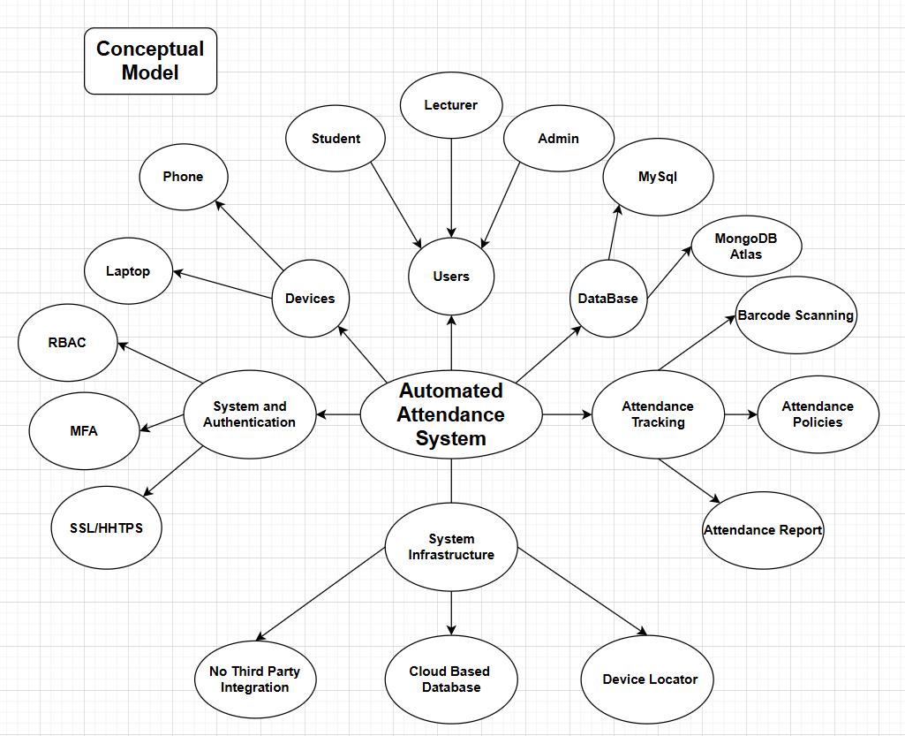

- Core System: Automated Attendance System
This is the central entity that connects all aspects of attendance management, security, infrastructure, and user interactions.
- Users
The system has three types of users:
- Lecturer – Responsible for managing attendance and reports.
- Student – Attends classes and gets recorded in the system.
- Admin – Manages system settings, authentication, and device registration.
- Devices
The system supports different devices for taking attendance:
- Phone
- Laptop These devices are used by lecturers and students to interact with the system.
- System and Authentication
Security features included in the system:
- RBAC (Role-Based Access Control) – Ensures that users can only perform actions based on their roles.
- MFA (Multi-Factor Authentication) – Adds an extra layer of security.
- SSL/HTTPS – Ensures secure communication between users and the system.
- Database
The system supports multiple databases for storing attendance records:
- MySQL – A relational database option.
- MongoDB Atlas – A NoSQL cloud-based database.

- Attendance Tracking
The system tracks attendance using:
- Barcode Scanning – Likely used for scanning student IDs or QR codes for attendance.
- Attendance Policies – Defines rules for marking attendance.
- Attendance Report – Generates reports for analysis.
- System Infrastructure
The system infrastructure ensures reliability and performance:
- No Third-Party Integration – The system is standalone and does not depend on external services.
- Cloud-Based Database – Data is stored in the cloud for better accessibility.
- Device Locator – Helps track lost or registered devices.
- Flow of the System Users (Students, Lecturers, Admins) interact with the system using their devices.
- Authentication (RBAC, MFA, SSL/HTTPS) ensures secure access.
- Attendance is tracked using barcode scanning and recorded in the database (MySQL/MongoDB).
- The system applies attendance policies and generates reports.
- Admins manage the system and devices while ensuring security and reliability.

CONCEPTUAL UML CLASS DIAGRAM
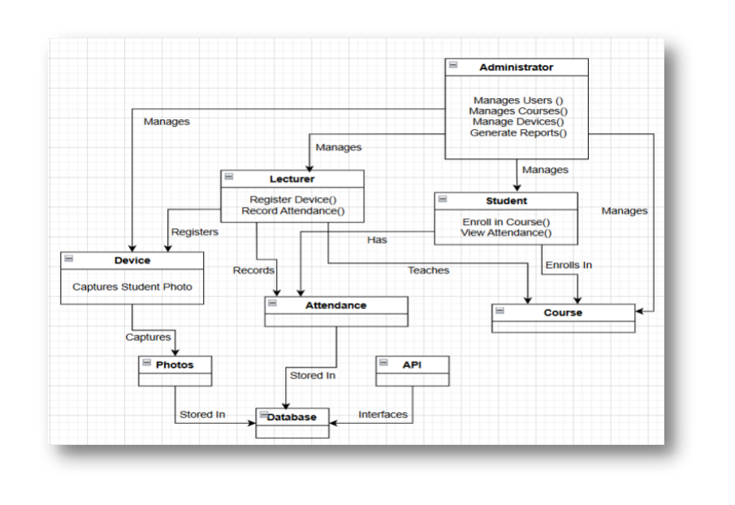

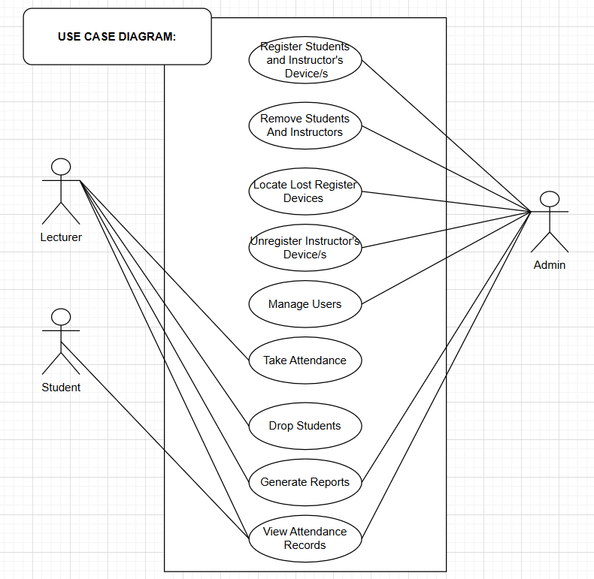

Frontend (Client Side)
•Web & Mobile App (React/Flutter) - Interface for lecturers, students, and administrators.
•Camera Module - Captures student photos for attendance records.
Backend (Server Side)
•REST API (Node.js/Express) - Handles requests from the frontend.
•Authentication Module - Manages user login/logout.
•Attendance Processing Module - Records student attendance.
•Report Generation Module - Generates attendance reports.
•Device Tracking Module - Locates registered devices.

Database (Cloud-Based MySQL)
•User & Role Management - Stores user details (students, lecturers, admins). •Course & Enrollment Data - Tracks which students are enrolled in which courses. •Attendance Records - Stores attendance data.
•Photo Storage - Stores student photos for verification.
External Services (Optional Enhancements)
•Cloud Storage (AWS S3, Firebase Storage) - Stores student images.
•GPS Tracking API (Google Maps API) - Locates lecturer devices.
•Notification Service (Twilio, Firebase Cloud Messaging) - Sends reminders for attendance.


Actors:
- Lecturer - A user who interacts with the system to take attendance, manage students, and view attendance records.
- Student - A user whose attendance is tracked and can view their attendance records.
- Admin - A system administrator responsible for user management, device registration, and maintenance of the system.

Use Cases and Flow:
Each oval represents a use case (a function or interaction with the system). The lines connecting the actors to the use cases show their interaction.
- Register Students and Instructor’s Device/s
The Admin registers devices for students and lecturers to be used in the system.
- Remove Students and Instructors
The Admin can remove students or lecturers from the system when they are no longer active. Locate

- Lost Registered Devices
The Admin has the ability to track and find registered devices if they are lost.
- Unregister Instructor’s Device/s
The Admin can remove an instructor’s device from the system.
- Manage Users
The Admin is responsible for adding, updating, and managing users in the system.
- Take Attendance
The Lecturer takes attendance using the system.
Students participate in the attendance process.
- Drop Students
The Lecturer can drop students from a course if necessary.
- Generate Reports
The Lecturer can generate reports on student attendance.
- View Attendance Records
Both Students and Lecturers can view attendance records.
Flow of Interaction:
- Admin sets up the system by registering devices and managing users.
- Lecturers take attendance using registered devices.
- Students' attendance is recorded in the system.
- Lecturers and students view attendance records.
- Admin maintains the system by adding/removing users and handling lost devices.
- Lecturers generate reports on attendance trends.
- If necessary, students can be dropped by the lecturer.

Attendance records are successfully stored in the database.
Reports are accessible to lecturers and administrators.
Students can view their attendance status

